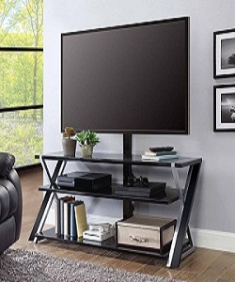

TV Trolley

$65.35

Availability: In stock

Description

Standard Finish in Black or Extra White are Available. Satin stainless steel frame, Concealed wiring, Glass shelf, Swivel functionality, which decor your TV lounge.